PipeLine Summary 8-3
Introduction 8-3
Shipment Costs by Supplier Report 8-3
Shipment Orders Report 8-3
Consumption Graph/Export 8-3
Couple-Years of Protection (CYP) Graph 8-3
Access the PipeLine Summary Module 8-3
Selecting Programs 8-4
Adding Programs 8-4
Creating Reports and Graphs 8-6
Shipment Costs by Supplier Report 8-6
Shipment Order Report 8-10
Consumption Graph/Export 8-12
Graph Type 8-12
Exporting Summary Consumption Graph Data 8-14
Couple-Years of Protection (CYP) Graph 8-16
Creating the CYP Graph 8-16
Displaying the Summary CYP Graph 8-18
Exporting the CYP Graph 8-18
CYP Graph 8-18
FPPMES 8-18
Previewing and Printing a Report or Graph 8-20

Pipeline SUMMARY
Figure 8-1—Select Programs screen 8-4
Figure 8-2 — Program ID window 8-4
Figure 8-3—PipeLine Summary Shipment Costs by Supplier screen 8-8
Figure 8-4—PipeLine Summary Shipment Order Report screen 8-10
Figure 8-5 – PipeLine Summary Consumption Graph screen 8-12
Figure 8-6—Graph options 8-14
Figure 8-7—Forecast options 8-14
Figure 8-8—Output window 8-16
Figure 8-9—PipeLine Summary CYP graph screen 8-17
Figure 8-10—Graph type selection 8-17
Figure 8-11—CYP Graph display 8-18
Figure 8-12—Export CYP Data window 8-18

PipeLine Summary

Introduction
This option (only available in English) is intended for program managers and/or consultants who are responsible for managing multiple programs tracked by PipeLine. It aggregates PipeLine data from selected programs, and arranges the data so it can be presented in a selected graph or report.

The following graphs and reports are available:

Shipments by Supplier Report
This report is similar to the PipeLine Shipment Summary report. It displays shipment costs, including product and freight costs, for selected supplier/status of selected, aggregated programs.

Shipment Orders Report
This report is similar to the PipeLine Shipment Orders report. It displays quantities and cost of orders for a selected supplier/status of selected, aggregated programs.

Consumption Graph/Export
This graph is similar to the PipeLine Consumption graph. It produces a monthly or quarterly bar chart showing actual and forecast consumption by product or method of selected, aggregated programs. This option enables you export aggregated data.

Couple-Years of Protection (CYP) Graph
This graph is similar to the PipeLine couple-years of protection (CYP) graph. It produces a monthly or quarterly bar chart showing actual and forecast CYP by product or method of selected, aggregated programs.

Access the PipeLine Summary Module
The PipeLine Summary Module is accessed through PipeLine.

From the Menu Bar—

- Click on the Tools option of the Menu Bar to display the Tools pull-down menu.

- Click on the PipeLine Summary pull-down menu option to display the PipeLine Summary menu screen.

Selecting Programs
The Select Programs option enables you select the program(s) to aggregate. You must select a program or programs for aggregation before you create reports or graphs.

From the PipeLine Summary Menu—

- Click on the Select Programs button.

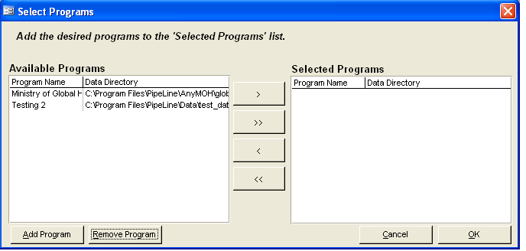
Figure 8-1—Select Programs screen PipeLine displays the Select Program screen (see Figure 8-1).

If the program (or programs) you need to aggregate does not appear on the list of available programs, you can add them.

Adding Programs
Use the Add Program button to add programs for selection and aggregation.

- Click on the Add Programs button.

PipeLine displays the Load Database window.

- Locate the data file corresponding to the program you want to add.

- Click on the program you need, then click on the Open button.
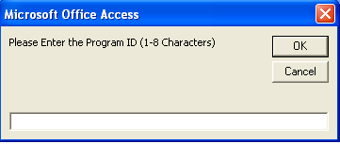
Figure 8-2—Program ID window
PipeLine displays a window similar to Figure 8-2 to enable you to associate an eight-character ID with the selected program.’

- Type the program’s eight-character ID.

- Click on the OK button to save the ID, and close the Program ID window.

The selected program is displayed in the Available Programs window on the Select Program screen.

- Repeat the process until you have added all the programs you need.

After your list is complete, you must select the programs you need to aggregate for reporting. This can be done in two ways:

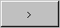
- 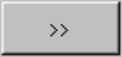Click on the Select All button to move the programs in the Available Programs window to the Selected Programs window.
Or, click on the program you need, and click on the Select button to move it from the Available Programs window to the Selected Program window.

- Repeat, as needed.

After you select the programs you need—

- Click on the OK button to aggregate the data and return to the PipeLine Summary menu.

Creating Reports and Graphs
 | If you make changes to a program’s data in PipeLine, you must reload the program into PipeLine Summary to ensure that the changes are reflected in the summary reports and graphs. To do this, reselect the program and regenerate the aggregated PipeLine Summary to reflect the changes you made.
PipeLine can create summary reports and graphs.

Shipment Costs by Supplier Report
The Shipment Costs by Supplier report groups shipment quantities and costs by supplier, method, product, program, and status.

This is useful if you have shipments going to multiple programs from the same supplier and you need to look at total shipments and associated costs for each supplier.

Use this report to review shipment information (including schedules and budgets) for a selected set of programs.

From the PipeLine Summary Menu—

- Click on the Shipments by Supplier Report button.

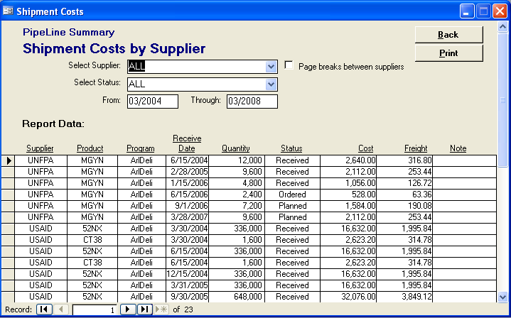
Figure 8-3—PipeLine Summary Shipment Costs by Supplier screen PipeLine displays shipments and their associated costs. Figure 8-3 shows the Shipment Costs by Supplier screen, which is displayed after the report is created. Use this screen to create shipment cost reports for other suppliers.

By default, the Shipment Costs by Supplier report is set for all products and all shipment statuses, with a reporting period of five years. To limit the report’s scope—

- Click on the arrow next to the Select Supplier field, and select a supplier from the pull-down menu.

- Click on the Select Status field and select the shipment status you want.

- Click on the From field, and type the beginning date of the report.

- Click on the Through field, and type the ending date of the report.
 | Always enter a four-digit year (e.g., 2003, 2004, 2005, etc.).

The Page Breaks Between Suppliers fields enable you to include page breaks between suppliers listed in the report (when the report is generated for more than one supplier).

- Click on the Page Breaks Between Suppliers field to include page breaks between suppliers.

See page 21 for information on printing the Shipment Costs by Supplier report.

Shipment Order Report
The Shipment Order report groups shipments by status, supplier, method, and product. Shipments with status planned are grouped under “New shipments requested this order.” Shipments with status shipped or status ordered are grouped under “Confirmation of shipments previously ordered and expected.” Shipments with status received are grouped under “Shipments received (in report range).”

This is useful if you have shipments to multiple programs and you need to look at which shipments need to be ordered or confirmed with the suppliers or donors.

Use this report to review shipment status information (including schedules and costs) for a selected set of programs. Select a single supplier. Present this report to that supplier to order planned shipments, confirm previously ordered shipments, and confirm receipt of shipments received from the supplier during the report period.

From the PipeLine Summary Menu—

- Click on the Shipment Order Report button.

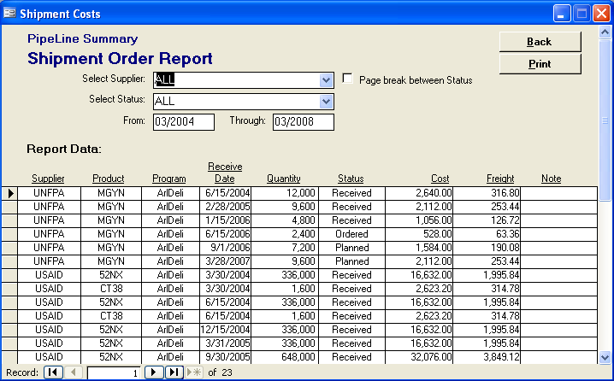
Figure 8-4—PipeLine Summary Shipment Order Report screen PipeLine displays orders and associated data for the selected programs. Figure 8-4 shows a sample of the Shipment Order report screen. By default, the Shipment Order report is set for all products and all shipment statuses with a five-year reporting period.

To limit the report’s scope—

- Click on the arrow next to the Select Supplier field, and select a supplier from the pull-down menu.

- Click on the Select Status field, and select the shipment status you need.

- Click on the From field, and type the beginning date of the report.

- Click on the Through field, and type the ending date of the report.
 | Always enter a four-digit year (e.g., 2003, 2004, 2005, etc.).

The Page Breaks Between Status fields enable you to include page breaks between the shipment statuses listed in the report (when the report is generated for more than one shipment status).

- Click on the Page Breaks Between Status field to include page breaks between shipment statuses.

See page 21 for information on printing the Shipment Order report.

Consumption Graph/Export
The Consumption graph groups consumption data by product ID or method ID.

Use this graph to compare relative shares and trends of distribution by product or method for multiple programs.

If you choose Method, the colors and legend will indicate what products and what programs are represented by each Method ID bar. If you choose Method and Program Detail, you will see the relative shares of each program, but not the product.

This is useful when programs use different but comparable products, so the method distinction is more useful than the product distinction.

From the PipeLine Summary Menu—

- Click on the Consumption Graph/Export button.

The graph is based on the last product/method and period updated or displayed. Figure 8-5 shows the Consumption Graph screen, which is displayed after the graph is created. Use this screen to create graphs for other products/methods.
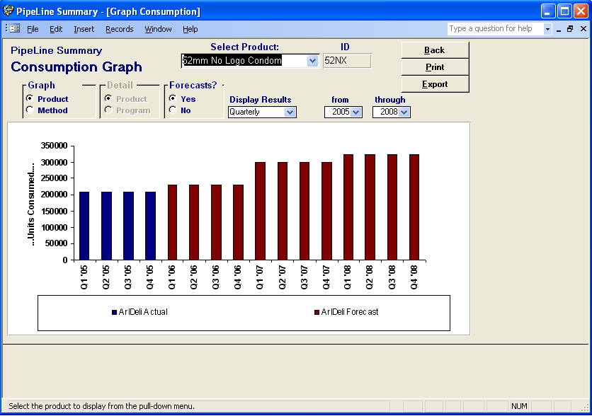
Figure 8-5—PipeLine Summary Consumption Graph screen

Graph Type
This section of the screen
enables you to determine the type of graph you will produce. Your options are Product or Method.

- To create a graph by product, click on the arrow next to the Select Product field, and select a product from the pull-down menu.
Or, click on the Method field (under Graph, see Figure 8-6). Click on the arrow next to the Select Method field, and select a method from the pull-down menu to create a graph by method.
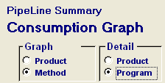
Figure 8-6—Graph options

When you create a consumption graph by method, the Detail section of the Consumption Graph screen becomes active (see Figure 8-6). Product is selected by default, enabling you to create a graph for products associated with a selected method.

To create a graph for all products of a particular method through an aggregation of programs—

- Click on the Program field (under Detail, see Figure 8-6).

- Click on the arrow next to the Select Method field, and select a method from the pull-down menu.

Regardless of the type of graph you choose, select the remaining options.

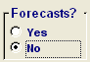
Figure 8-7—Forecast options By default, the graph includes consumption forecasts. To create a graph that excludes forecast data—

- Click on the No field (see Figure 8-7).

- Click on the arrow next to the Display Results field, and select Monthly to display the data by month, or Quarterly to display the data by quarter.

The default reporting period is five years (the previous two years, current year, and following two years). To change the default reporting period—

- Click on the arrow next to the From field, and select the starting year of the report period.

- Click on the arrow next to the Through field, and select the last year of the report period.

See page 21 for information on printing the Consumption graph.

Exporting Summary Consumption Graph Data
Summary Consumption graph data can be exported for use with Microsoft Excel or other analysis software. After you create a consumption graph for a product or method—

- Click on the Export button.

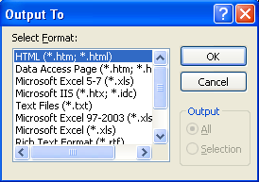
Figure 8-8—Output window PipeLine displays the Output window (see Figure 8-8).

- Click on the file type for the export data.

- Click on the OK button.

PipeLine opens another Output window, so you can name and save the export file.

- Click on the OK button.
Or, click on the File Name field, and type the new export file name.

- Click on the OK button to export and save the Consumption graph.

- Click on the Back button to return to the PipeLine Summary menu.

Couple-Years of Protection (CYP) Graph
The CYP Graph converts consumption data by the CYP factor associated with a method.

Use this graph to measure and compare the extent of coverage provided by product or method across programs. The CYP factor is based on the percentage of one year where one unit of the method would provide one couple with contraception, if used properly.

You can compare coverage achievement over time between programs despite differences in method mix. A social marketing program may distribute more units and more volume and, perhaps, more value with methods like condoms and orals. But, a CYP analysis may indicate that a clinic NGO or MOH program may achieve more coverage because of the greater CYP factors of long-term methods such as Norplant, Depo-Provera, and IUDs.

Use this graph to evaluate and monitor relative program coverage or national coverage and achievement.

Creating the CYP Graph
Create the CYP graph as follows.

From the PipeLine Summary Menu—

- Click on the Couple-Years of Protection (CYP) Graph button.

Figure 8-9 is a sample PipeLine Summary CYP graph screen.

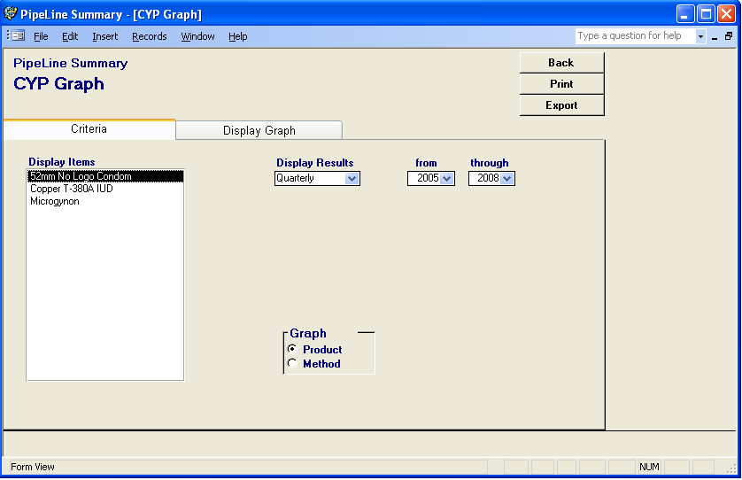
Figure 8-9—PipeLine Summary CYP graph screen
The Display Items field shows the products or contraceptive methods that can be included in the graph.

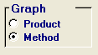
- Figure 8-10—Graph type selection Click on the Method option (Under Graph, see
Figure 8-10) to create a graph by method.
Or click on the Product option (Under Graph,
see Figure 8-10) to create a graph by product.

After you set the graph for products or methods—

- Click on the product (or method) you want to include.

To select multiple products (or methods)—

- Hold down the Control key (<Ctrl>) and click on each product or method you want to include.

- Click on the arrow next to the Display Results field, and select Monthly to display the data by month or Quarterly to display the data by quarter.

- Click on the arrow next to the From field, and select the starting year of the report period from the pull-down menu.

- Click on the arrow next to the Through field, and select the last year of the report period from the pull-down menu.

Displaying the Summary CYP Graph
Use the Display Graph tab to preview the CYP graph before printing it.

- Click on the Display Graph tab.

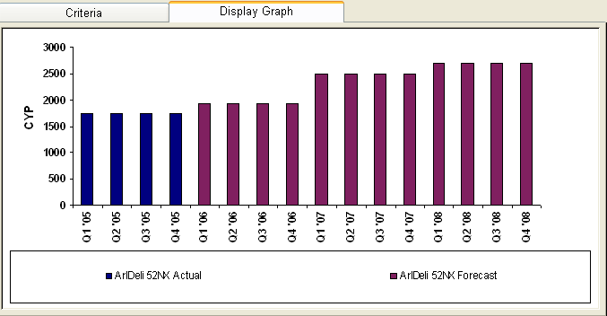
Figure 8-11—CYP Graph display The CYP graph is created and displayed (see Figure 8-11).

See page 21 for information on printing the PipeLine Summary CYP graph.
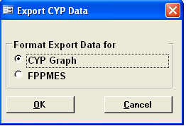

Figure 8-12—Export CYP Data window Exporting the CYP Graph
The Export button enables you to export the data of a completed PipeLine Summary CYP graph. After you create a CYP graph, you can export the data as follows—

- Click on the Export button.

PipeLine displays the Export CYP Data window (see Figure 8-12). Use the options in this window to arrange the data in a Microsoft Office Excel spreadsheet.

CYP Graph
Incorporates the CYP factors into the consumption totals for ad hoc reports and graphs.

FPPMES
Arranges the data for the Family Planning Program Monitoring and Evaluation System.

The default is CYP Graph.

- Click on the OK button to accept the default.
Or, click on FPPMES, and click on the OK button.

PipeLine opens another Output window where you can name and save the export file. The default export file name is shown in the File Name field.

- Click on the OK button to accept the default.
Or, click on the File Name field, and type the new export file name.

- Click on the OK button to export, and save the Consumption graph.

- Click on the Back button to return to the PipeLine Summary menu.

Previewing and Printing a Report or Graph
The procedure for printing a PipeLine Summary report or graph is the same regardless of the type you choose. To print a completed report or graph—

- Click on the Print button to display the report or graph on your screen.

- Click on the print icon to send the report or graph to your default printer.

- Click on the close icon to return to the previous screen.

- Click on the Back button to return to the PipeLine Summary menu.

